**Benefits of the Program**

# 2021 CVS Health & Roger Williams University CWPD Executive Learning Series Nomination Form

Thank you for taking the time to complete this nomination and for your partnership in providing growth and development opportunities for diverse suppliers. The benefits of participating in this program are varied and each diverse supplier will find value in this program provided they engage fully.  This program is comprised of six (6) major components; Online Instruction (Synchronous & Asynchronous), Executive Coaching, Mock RFP Exercise, Capstone Presentations, and Networking Opportunities.

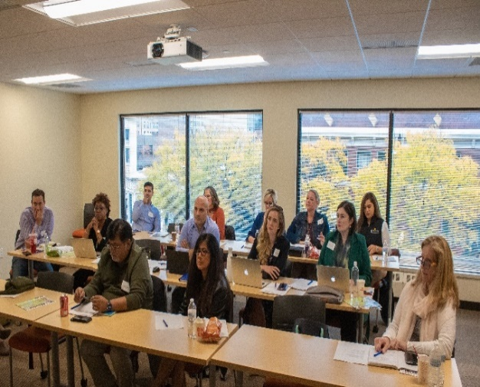

**SYNCHRONOUS INSTRUCTION**

The synchronous instruction allows for the diverse suppliers, instructors, and panelists to interact with each other. A few of our synchronous engagements include topics such as; RFP/RFQ Purchasing/Contracting, Business Innovation & Leading Change, CVS Procurement 101, and Production Planning, Systems Thinking & Design.

**ASYNCHRONOUS ONLINE INSTRUCTION**

These courses allow the diverse supplier to engage with the material at their own pace.  The three main courses include Content Marketing (Social Media Exploration), Understanding & Evaluating Capital Business Decisions, Process Improvement & Strategic Planning.

**MOCK RFP**

Part of the experience includes responding to a mock RFP.  This exercise is a key component of the program and will allow the diverse supplier to get firsthand experience with the technology, as they would with a real-world RFP.  There will be multiple scopes of work in the Mock RFP to review and choose from in order to best draft a response.

**CAPSTONE PRESENTATION**

This presentation allows an opportunity to go before a panel of judges, including members of the CVS Health Sourcing, Contracts and Vendor Management teams, as well as RWU faculty.

**EXECUTIVE COACHING**

Diverse suppliers receive executive coaching throughout the program.  The coaches are matched to the focus area chosen by the diverse supplier.  Coaching can help to clarify business goals and objectives and helps to develop skills needed to operate a successful enterprise.  Some other benefits include:

* Offer new perspective on existing challenges and/or opportunities within the business
* A thought partner that provides feedback and direction

**NETWORKING**

One of the biggest benefits of participating in the Executive Learning Series is the connection amongst business owners, entrepreneurs, CVS Health staff, instructors and coaches.  Networking is a great opportunity to exchange best practice knowledge, learn about business techniques of peers and stay up to date with the latest industry developments. A varied and wide network of informed, interconnected contacts means more access to new, valuable, and pertinent information.More rewarding still, is the fact that through networking diverse suppliers will also be able to help others by sharing their expertise and connections.

**TO BE COMPLETED BY DIVERSE SUPPLIER:**

Diverse Supplier Nomination Form

1. **Nominating Council:** Click or tap here to enter text.
2. **Diverse Supplier’s Company Name:** Click or tap here to enter text.
3. **Diverse Supplier Participant Name:** Click or tap here to enter text.
   1. ***Please Note:*** *the participant should be the owner/CEO or someone in a leadership position.*
4. **Diverse Supplier Participant Email Address:** Click or tap here to enter text.
5. **Diverse supplier Participant Phone Number:** Click or tap here to enter text.
6. **Company Website (if available):** Click or tap here to enter text.
7. **Company Headquartered State:** Click or tap here to enter text.
8. **Company Diversity Category(s):** Click or tap here to enter text.
9. **Diverse Company Ownership Ethnicity:** Click or tap here to enter text.
10. **How many years has the company been in business?:** Click or tap here to enter text.
11. **Is the company a Category 1 or Category 2 supplier? (Choose from drop down):** Choose an item.
12. **What is the diverse supplier’s 2020, 2019, and 2018 revenue?** 
    1. **2020 Revenue:** Click or tap here to enter text.
    2. **2019 Revenue:** Click or tap here to enter text.
    3. **2018 Revenue:** Click or tap here to enter text.
13. **How many full time/part time W-2 employees does the company have?** Click or tap here to enter text.
14. **What product/service does the diverse supplier provide?** Click or tap here to enter text.
15. **Please provide a brief description of the products/services provided by the diverse supplier?** Click or tap here to enter text.
16. **Has the diverse supplier taken part in any other executive learning/training programs?** Choose an item.
    1. **If so, which programs has the diverse supplier taken part in?** Click or tap here to enter text.
17. **Which, if any, Fortune 500 companies is the diverse supplier doing business with?** Click or tap here to enter text.
18. **If selected for the program, you will have an opportunity to engage in Executive Coaching for up to 10 hours with a qualified professional. Please choose your top 3 areas of interest from the list below. Although we try to assign your first area of focus, please keep in mind that you may be assigned your second, or third choice.**

Business Innovation

Communications/Public Speaking

Finance/ Budget

Human Resource and Communications

Leadership Development & Organizational Culture

Marketing

Production Planning and/or Systems Thinking

RFP/RFQ/RFI/Proposal Writing

* 1. **Please rank the choices you selected above. 1 being your top choice and 3 being your last choice:**

**1.**

**2.**

**3.**

1. **Diverse Supplier’s Certification Number and Expiration Date:**
2. **Please provide a copy of the diverse supplier’s certification:** *Include as an attachment in email.*
3. **If selected, are you willing and able to participate in the program? (Please choose from drop down):** Choose an item.
   1. ***Please Note:*** *all program courses and events will be planned using Eastern Standard Time (EST).*

**TO BE COMLPLETED BY NOMINATING COUNCIL:**

1. **Please provide a few reasons why you are nominating this supplier to be part of the 2021 CVS Health & Roger Williams University CWPD Executive Learning Series Program?** Click or tap here to enter text.
2. **Please explain how you think the CVS Health & Roger Williams University CWPD Executive Learning Series Program will positively impact this diverse supplier’s business?** Click or tap here to enter text.



**Date:** Click or tap to enter a date. **Date:** Click or tap to enter a date.

